***Feng Shui arowana fish***

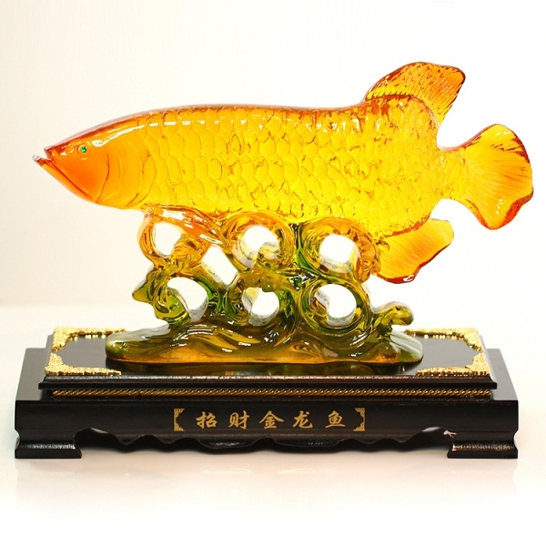

*The feng shui arowana has a base made of solid natural wood, and the body of the fish is made of high-quality plastic. High finish with sharp simulated details. Feng shui arowana fish means wealth, wealth and fortune for the owner. The product is very suitable as a housewarming gift, a gift for a boss.*